**SECOND TERMINAL EXAMINATION**

**COMPUTER - CLASS II** Max mark -40

**I Choose the correct option from the bracket (1x8=8)**

1. Which one is called a pointing device?

(Keyboard, Mouse, Printer, Hard disk)

1. Which of the following is not used to store data?

(CD, DVD, Pen drive, UPS)

1. Which one of these is an input device

(Microphone, Speaker, Headphone, Printer)

1. The brain of a computer

(CPU, Mouse, Keyboard, UPS)

1. The key used to move the cursor to the next line

(Enter, Shift, Space bar, Backspace)

1. When this key is ON, the typed alphabets are displayed in capital

(Number Lock, Caps Lock, shift, none of these)

1. The key used to type the upper symbols with a key having two characters is

(caps lock, number lock, shift ,none of these)

1. How many enter keys are there on a keyboard

(2,1,3,5)

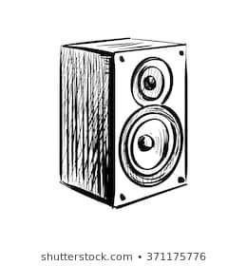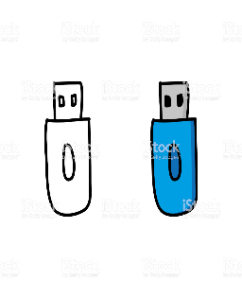**II Identify the picture (1x5=5)**

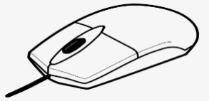a) b) c)

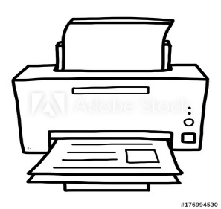

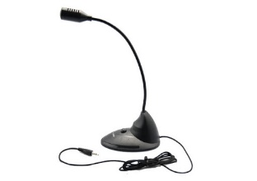d) e)

**III Answer in one or two word (1x6 =6)**

1. It is a small blinking line on the monitor
2. These keys move the cursor on the monitor in four direction
3. This key is used to erase things typed on right side of the cursor
4. This is a part of Computer look like TV
5. This is used to take print out
6. This control all parts of a computer

**IV Write T for true and F for false (1x6=6)**

1. There are two shift keys on the keyboard
2. The delete and backspace keys are used to erase text
3. If you want to type several letters in capital turn the caps lock key on
4. Pen drive can be easily carrying out in your pocket
5. Speaker can be used to listen to music without disturbing others
6. CD and DVD can store data

**V Categorise into input and output devices (1x5=5)**

Keyboard, printer, Mouse, headphone, speaker

**VI Answer the following (5x2=10)**

1. What are the four main parts of a computer?
2. What are input devices?
3. What is a cursor?
4. What is the use of cursor control keys?
5. List two uses of a mouse

…………………………………………………………………………………………………………………

**SECOND TERMINAL EXAMINATION**

**COMPUTER - CLASS I** Max mark -40

**I Choose the correct option from the bracket (1x8=8)**

1. ------------- is look like a TV

(Mouse, Monitor, CPU, Keyboard)

1. The brain of a computer is ---------------

(CPU, Mouse, Keyboard, monitor)

1. The keys keyboard should press -----------------

(gently, hard, roughly, all of these)

1. ------------ is generally used to select an object

(click, double click, drag and drop, right click)

1. ------------ is used to record different sounds

(Microphone, printer, mouse, keyboard)

1. We should use a ----------- cloth to clean the monitor

(clean and wet, clean and dry, dirty and dry, wet cloth)

1. Always sit at a/am ------------- length from monitor.

(hand’s, arm’s, none of these)

1. ------------ is used to print on paper

(printer, speaker, scanner, mouse)

**II Identify the picture (1x5=5)**

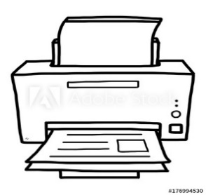****a)b) c)

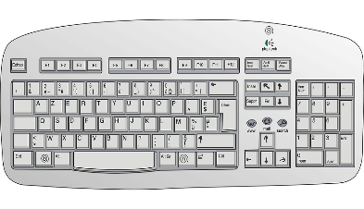

c) d)



[This Photo](https://commons.wikimedia.org/wiki/File:Devicetemplates_computer-02.png) by Unknown Author is licensed under [CC BY-SA](https://creativecommons.org/licenses/by-sa/3.0/)

**III Answer in one or two word (1x6 =6)**

1. The printed papers from the printout are called?
2. Name the special seat for a computer mouse?
3. Name the device use for scanning the photos or text into your computer
4. Name the tilted arrow seen on the monitor
5. Which part of a mouse will you use to scroll up and down the page?
6. To select a file, will you click or double click the mouse?

**IV Write T for true and F for false (1x6=6)**

1. A speaker used to take print out
2. A mouse helps us to point things on monitor
3. We should cover our computer when not in use
4. We can play with the mouse wires
5. The drag and drop action used to move an item from one position to another on monitor
6. A right click shows a list of things you can do

**V Match the following (1x5 =5)**

1. CPU This has keys on it
2. Keyboard Used to listen voice or music
3. Monitor This is the brain of computer
4. Mouse we can see pictures on it
5. Speaker We can draw pictures using this

**VI Answer the following (5x2=10)**

1. What are the four mouse actions?
2. When we should cover our computer?
3. What are the four main parts of computer?
4. How we can keep CD/DVD properly?
5. Write the full form of CPU

---------------------------------------------------------------------------

**SECOND TERMINAL EXAMINATION**

**PHYSICS - CLASS VIII** Max mark -40

**I Write answer in one sentence (1x7=7)**

1. What is the SI unit of force?
2. 1 HP =.............W
3. The speed of light in air or vacuum is-----------
4. The property of splitting of white light into its seven colours is known as-----------
5. Write equation for kinetic energy
6. How atmospheric pressure change with the altitude
7. Name the type of energy in a stretched rubber band

**II Answer the following (8x2=16)**

1. Which fact about liquid pressure does the diagram illustrate

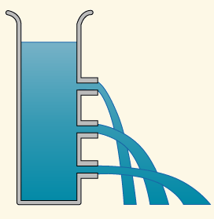

1. Explain turning effect of force with an example
2. State Snell's law
3. Explain why a tall building has wide foundations?
4. Write the difference between energy and power
5. State two factors on which potential energy of a body at certain height above the ground depends
6. Why we use convex mirror as a rear-view mirror of vehicle instead of plane mirror
7. Write the property of image formed by a concave mirror when the object is placed at
8. Infinity ii) at the focus

**III Short answer questions (3x3=9)**

1. Spanner of length 10 centimetre is used to open a nut by applying a minimum force of 5 Newton. Calculate the moment of force required in Newton metre
2. A man lifts a mass of 20 kilogram to a height of 2.5 metre. Assuming that the force of gravity on 1 kg mass is 10 Newton. Find work done by the man
3. Using a neat diagram explain refraction of light through a prism

**IV Long answer question (4x2=8)**

1. Explain why?
2. Early sunrise and late sunset
3. It is easy to open the door by pushing it at its free end
4. Spanner has long handle

14 i). A body of 20 N acts normally on a body having area of cross section 10 cm2. Calculate the pressure exert

ii) Give one example to show conversion of potential energy to kinetic energy when put in use

---------------------------------------------------------------------

**SECOND TERMINAL EXAMINATION**

**PHYSICS - CLASS VII** Max mark -40

**I Write answer in one sentence (1x7=7)**

1. Speed of light in air
2. The angle of incidence of plane mirror is 300 , then angle of reflection will be?
3. What is the SI unit of temperature?
4. Ice point of Fahrenheit scale is---------
5. How many numbers of divisions are there between ice point and steam point of Fahrenheit scale?
6. The ability to do work is called---------------
7. What are the factors depends kinetic energy of moving body?

**II Answer the following (8x2=16)**

1. Explain the terms conductors and insulators
2. i) What are primary colours

ii) Red + Blue=…………….

1. Two bodies A and B of masses 10 Kg and 20kG respectively are at same height above the ground which of them has greater potential energy? Why?
2. From the given figure find angle of incidence and angle of reflection

A

300  B

1. Define potential energy using appropriate example
2. State the energy change occur in i) Photosynthesis ii) Loud speaker
3. A rose appears red in white light. How will it appear in i) green light ii) red light?

Give reason

1. Write the difference between real image and virtual image

**III Short answer question (3x3=9)**

1. What are the two laws followed by light during reflection?
2. Convert 100 C in i) degree Fahrenheit ii) Kelvin
3. Write any two form of energy with suitable example

**IV Long answer question (4x2=8)**

1. Explain conduction, convection and radiation with suitable example
2. Explain why
3. We prefer to wear white cloth in summer
4. Why cooking pan provide with wooden or Ebonite handle

----------------------------------------------------------------------------------------